# Effective Data Cleaning and Preprocessing Techniques

**Purpose**

This guide provides a detailed roadmap for juniors to master data cleaning and preprocessing techniques tailored for open data projects. With clear examples, best practices, and practical tools, it ensures that data from sources like the City of Melbourne Open Data Portal is ready for analysis, free from errors, and consistent for insightful results.

**Introduction**

Data cleaning and preprocessing are the foundations of any data-driven project. Raw datasets often come with imperfections, such as missing values, duplicates, or inconsistent formats, which can lead to inaccurate analyses or misleading conclusions. This guide equips you with the skills to prepare clean, reliable datasets, ensuring your analyses are robust and reproducible.

**Why is Data Cleaning Important?**

* **Improved Accuracy:** Clean data eliminates errors, ensuring your results reflect reality.
* **Efficiency:** Pre-processed data minimizes time spent debugging and re-analysing.
* **Reproducibility:** Documented cleaning steps ensure others can replicate and trust your work.

**Steps for Effective Data Cleaning**

**1. Understanding the Dataset**

* **Review Dataset Documentation:** Familiarize yourself with the metadata provided, which explains each column and its significance.
* **Explore the Dataset:**
  + Use df.info() to identify data types and detect missing values.
  + Use df.describe() for an overview of numerical data.
  + Visual inspection via df.head() and df.sample() reveals potential anomalies.
* 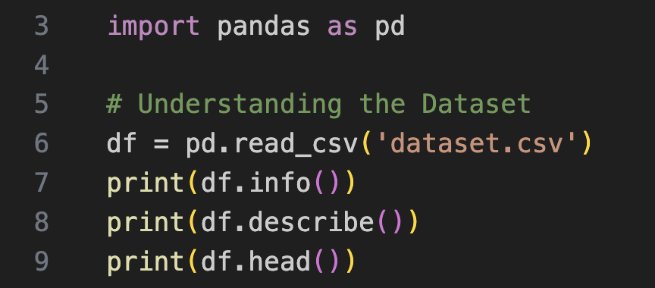**Example Code:**

**2. Handling Missing Values**

* A black background with green and white text

  Description automatically generated**Identify Missing Values:**
* **Strategies:**
* **Imputation:** Replace missing numerical values with the mean, median, or a predictive model's estimate.
* **Dropping:** Remove rows or columns with excessive missing values.
* **Placeholder Replacement:** Use "Unknown" for missing categorical data.
* A computer code on a black background

  Description automatically generated**Example Code:**

**3. Standardizing Formats**

* **Ensure consistency in:**
  + **Dates:** Convert to datetime objects.
  + **Numbers:** Remove non-numeric characters and convert to float or integer.
* 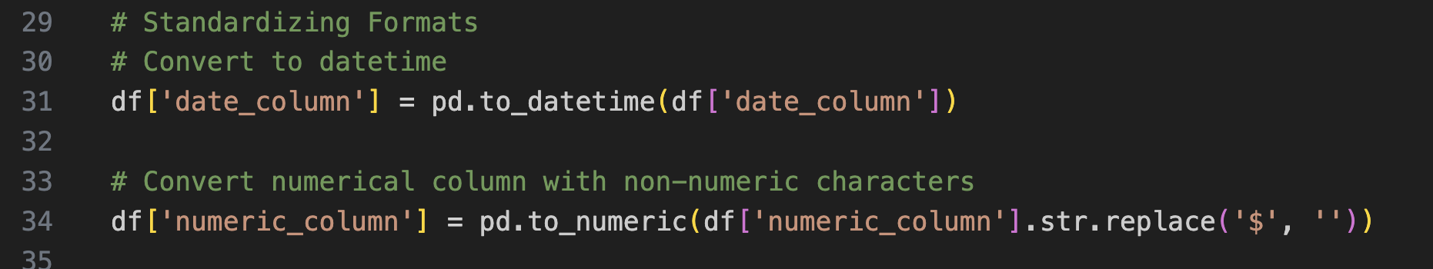**Example Code:**

**4. Removing Duplicates**

* A black background with white text

  Description automatically generatedDuplicate rows distort analysis. Detect and remove them with:

**5. Handling Outliers**

* **Detect Outliers:**
  + Use visualizations like boxplots.
  + A black screen with white text

    Description automatically generatedCalculate Interquartile Range (IQR):
* **Treat Outliers:**
  + Remove erroneous values.
  + Transform using log scaling for skewed distributions.

**Best Practices for Preprocessing**

1. **Normalization and Scaling**

**Why:** Algorithms like K-Nearest Neighbors (KNN) and neural networks are sensitive to data scales.

**Techniques:**

* + Min-Max Scaling: Scales values to [0, 1].
  + Standard Scaling: Centers data around zero with unit variance.

**Example Code:**

1. **Encoding Categorical Variables**

* **One-Hot Encoding:** Creates binary columns for each category.
* **Label Encoding:** Assigns numerical labels to categories.

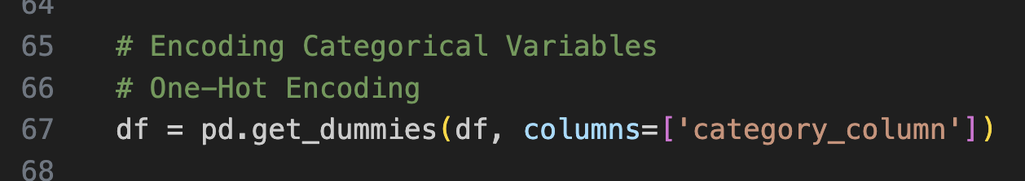**Example Code:**

**3. Feature Engineering**

* **Create New Features:**
  + Extract time-based features like "hour" or "day" from datetime columns.
  + Aggregate data for grouped insights.

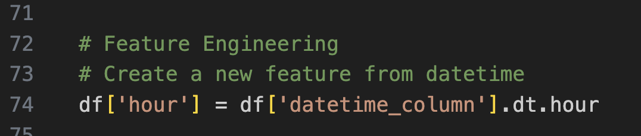**Example Code:**

**Tools for Data Cleaning**

**1. Pandas and NumPy**

* Core Python libraries for data manipulation and numerical computation.

**2. GeoPandas**

* Specialized for cleaning and analyzing geospatial data.

**3. OpenRefine**

* GUI tool for cleaning messy datasets (Eg:- fixing typos in categorical data).

**4. Pyjanitor**

* Provides additional functions for repetitive cleaning tasks.

**Common Pitfalls to Avoid**

* **Over-cleaning:** Avoid removing legitimate outliers or oversimplifying data.
* **Ignoring Metadata:** Always consult dataset documentation to understand nuances.
* **Lack of Reproducibility:** Document every step with comments and reusable code.

**Practical Examples**

**Example 1: Cleaning "On-Street Parking Data"**

* **Problem:** Missing availability data and inconsistent time formats.
* **Solution:**
  + Impute missing values with the mean for similar time slots.
  + Convert timestamps to datetime objects.

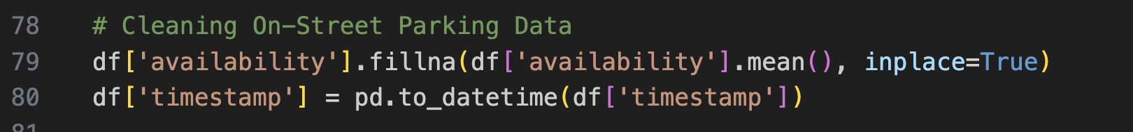**Code:**

**Example 2: Pedestrian Traffic Analysis**

* **Problem:** Duplicate hourly pedestrian counts.
* **Solution:**
  + Remove duplicates.
  + Aggregate by location and hour for average counts.

**Code:**

**Automation Tips**

* Write Python scripts for repetitive tasks.
* Save preprocessing steps as reusable functions.

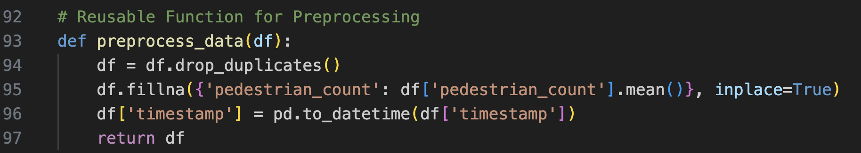**Reusable Function:**

**Additional Resources**

* [Pandas Documentation](https://pandas.pydata.org/docs/)
* [GeoPandas Documentation](https://geopandas.org/)
* [City of Melbourne Open Data Portal](https://data.melbourne.vic.gov.au)

**Author**

Kushani Imanthi Ranasinghe

(Created on 13.12.2024)